Example Microsoft Form Guidance
INTRODUCTION
We have created a pre-made survey that can be used by artists to gather audience feedback. This is working with Microsoft Forms. You will need to set up a Microsoft Account to use this. If you don’t wish to use Microsoft, you can access the questions here, to use with another platform of your choice.
To use this form, you will need to DUPLICATE it before making any changes. You are then able to add you own questions to personalise the questionnaire.
There is a bank of questions in Example Audience Survey Questionnaire Bank, which may be useful.
Please follow this process:
STEP 1: Click this link: Audience Survey – Copy form
> Choose the Duplicate it button circled in red
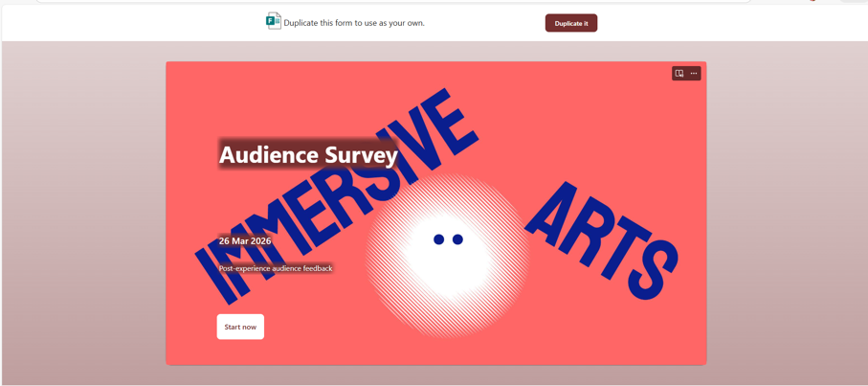

STEP 2: Once you have made a copy, you can add/delete questions, change the style, colours etc.
>Once it’s ready you click collect responses
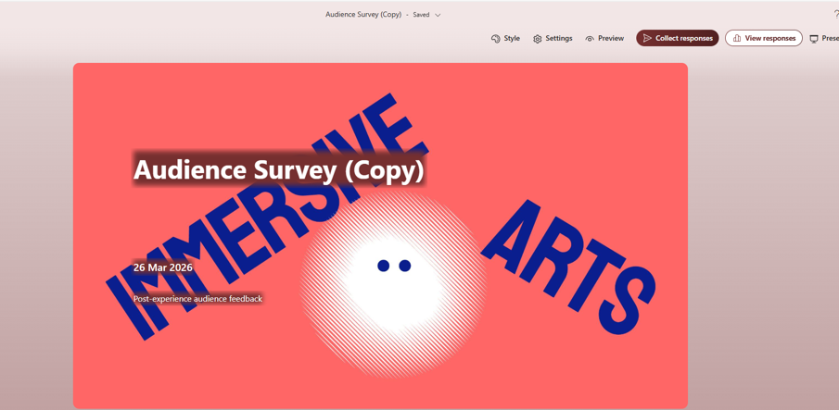
STEP 3: Copy the URL/Link or add contacts to share.
It can be useful to turn your link into a QR code for audiences to scan at your event.
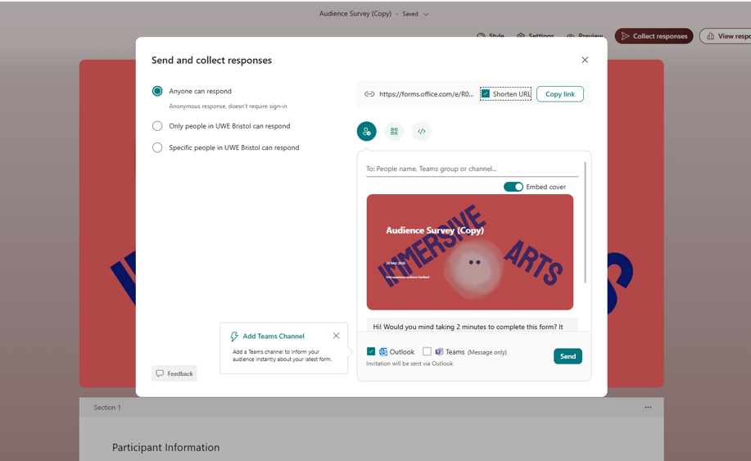
STEP 4: Once you have collected responses to your survey, you click View Responses
This feedback can then be downloaded for analysis.
Further Research on Audiences
For Immersive Arts to gain a wider view of audiences around the UK, we welcome any artist who would be happy to share some of the anonymised data they collect from audiences during their Immersive Arts project. This would involve asking audiences to ‘opt in’ to sharing this data with the Immersive Arts Programme.
If you do not wish to do this, you will need to delete Q2 on the existing survey.
This data must remain anonymised.
When you have collected your feedback, please email an Excel export to: research@immersivearts.uk
This will help us to better understand audiences for Immersive Art experiences.
If you have further questions about this, or any of the Audience Evaluation Resources, please contact: kerryn.wise@uwe.ac.uk

